**Contingency Analysis of income_level By AGE_DESC**

**spending_more=TRUE**

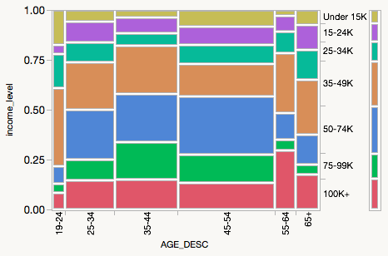

**AGE_DESC by income_level**

|  |  |  |  |  |  |  |  |  |
| --- | --- | --- | --- | --- | --- | --- | --- | --- |
| Count  Deviation  Cell Chi^2 | 100K+ | 75-99K | 50-74K | 35-49K | 25-34K | 15-24K | Under 15K | Total |
| 19-24 | 2  -1.5572  0.6817 | 1  -1.9237  1.2658 | 2  -3.4576  2.1905 | 9  3.78602  2.7491 | 4  1.75847  1.3795 | 1  -1.0953  0.5726 | 4  2.48941  4.1025 | 23 |
| 25-34 | 13  -0.6102  0.0274 | 9  -2.1864  0.4273 | 22  1.11864  0.0599 | 21  1.05085  0.0554 | 9  0.42373  0.0209 | 9  0.98305  0.1205 | 5  -0.7797  0.1052 | 88 |
| 35-44 | 17  -0.322  0.0060 | 21  6.76271  3.2123 | 27  0.42373  0.0068 | 27  1.61017  0.1021 | 7  -3.9153  1.4044 | 9  -1.2034  0.1419 | 4  -3.3559  1.5310 | 112 |
| 45-54 | 23  -3.6017  0.4876 | 25  3.13559  0.4497 | 50  9.18644  2.0677 | 28  -10.992  3.0985 | 16  -0.7627  0.0347 | 16  0.33051  0.0070 | 14  2.70339  0.6469 | 172 |
| 55-64 | 11  5.27754  4.8672 | 2  -2.7034  1.5538 | 5  -3.7797  1.6272 | 11  2.61229  0.8136 | 4  0.39407  0.0431 | 3  -0.3708  0.0408 | 1  -1.4301  0.8416 | 37 |
| 65+ | 7  0.81356  0.1070 | 2  -3.0847  1.8714 | 6  -3.4915  1.2844 | 11  1.9322  0.4117 | 6  2.10169  1.1331 | 5  1.35593  0.5045 | 3  0.37288  0.0529 | 40 |
| Total | 73 | 60 | 112 | 107 | 46 | 43 | 31 | 472 |

Warning: 20% of cells have expected count less than 5, ChiSquare suspect.

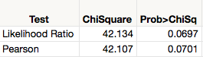

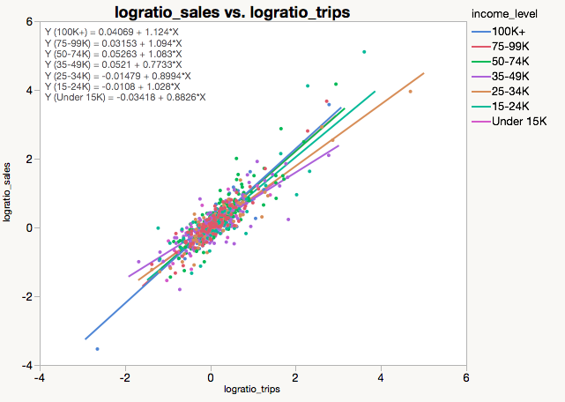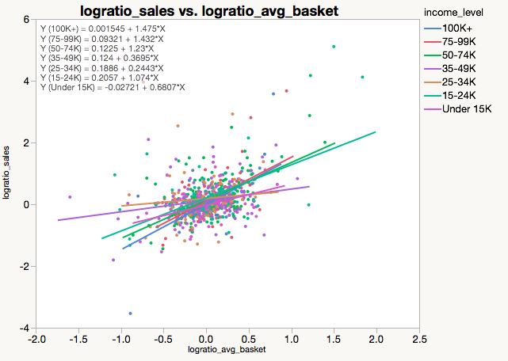

 

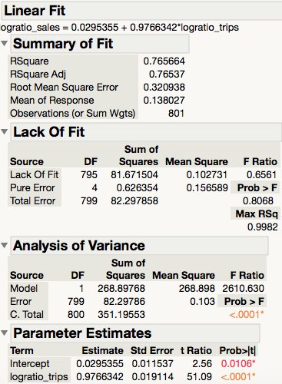 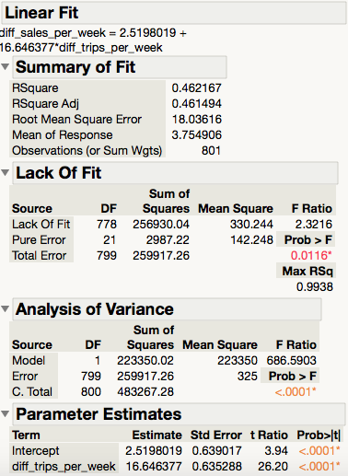

number of households spending more

